**Ex. No. : 4.1 Date:**

**Register No.: 231401011 Name:ANURAHINI S**

[**Factors of a number**](https://www.rajalakshmicolleges.net/moodle/mod/quiz/view.php?id=5720)

Determine the factors of a number (i.e., all positive integer values that evenly divide into a number).

**For example:**

| **Input** | **Result** |
| --- | --- |
| 292 | 1 |
| 1015 | 2 |
| 108 | 3 |
| 22 | 0 |

**PROGRAM**

def digits (n) :

count=0

for digit in range (10) :

if str(n).count(str(digit))==1:

count+=1

return count

n=int (input ())

print( digits (n) )

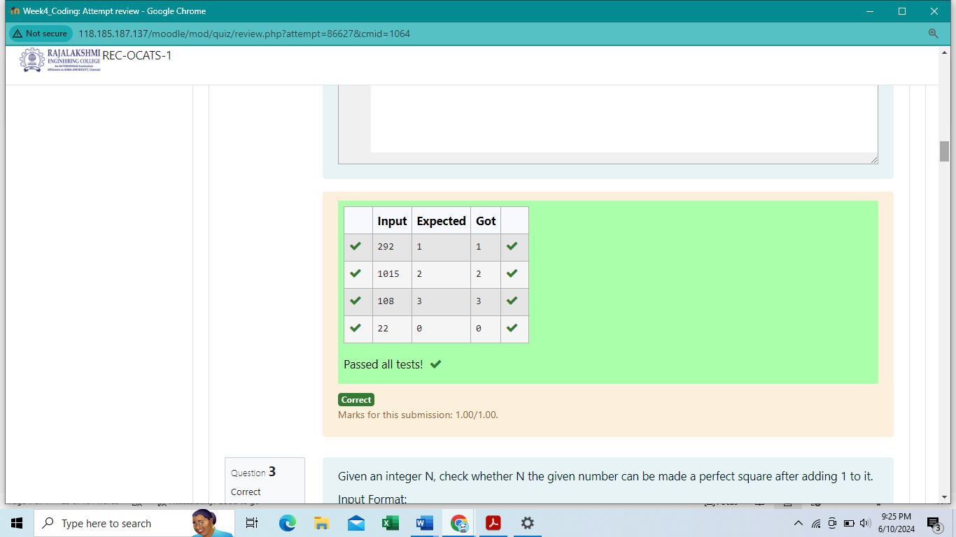

**Ex. No. : 4.2 Date:**

**Register No.: 231401011 Name: ANURAHINI S**

[**Non**](https://www.rajalakshmicolleges.net/moodle/mod/quiz/view.php?id=5717) **Repeated Digit Count**

Write a program to find the count of non-repeated digits in a given number N. The number will be passed to the program as an input of type int.

Assumption: The input number will be a positive integer number >= 1 and <= 25000.

Some examples are as below.

If the given number is 292, the program should return 1 because there is only 1 non-­repeated digit '9' in this number

If the given number is 1015, the program should return 2 because there are 2 non-repeated digits in this number, '0', and '5'.

If the given number is 108, the program should return 3 because there are 3 non-­repeated digits in this number, '1', '0', and '8'.

If the given number is 22, the function should return 0 because there are NO non-­repeated digits in this number.

Example1: if the given number N is 7, the method must return 2

Example2: if the given number N is 10, the method must return 1

**For example:**

| **Input** | **Result** |
| --- | --- |
| 7 | 2 |
| 10 | 1 |

**Program**

n=int (input ( ))

f=0

for i in range (2, n) :

if n%i==0:

f=1

Break

if f==1:

print(1)

else :

print(2)

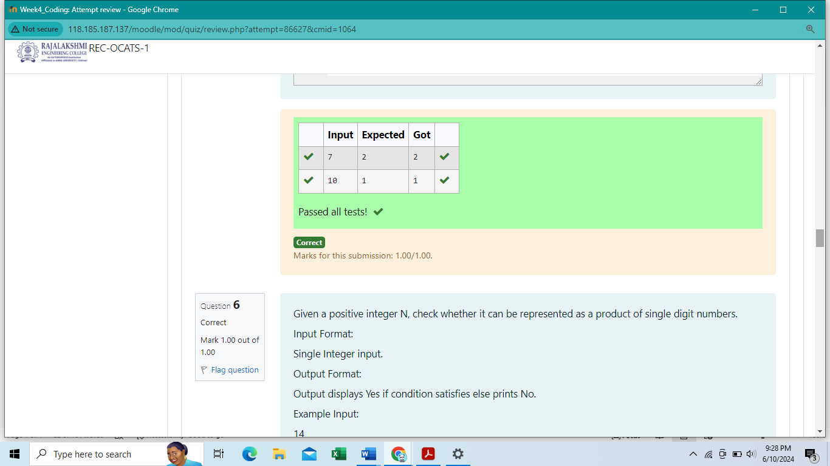

**Ex. No. : 4.3 Date:**

**Register No.: 231401011 Name: ANURAHINI S**

**Prime Checking**

Write a program that finds whether the given number N is Prime or not. If the number is prime, the program should return 2 else it must return 1.

Assumption: 2 <= N <=5000, where N is the given number.

Input Format:

Integer input from stdin.

Output Format:

Perfect square greater than N.

Example Input:

10

Output:

16

**Program**

def square (n) :

if(n%4==0):

return "Yes"

else:

return "No"

n=int (input ( ))

print (square (n))

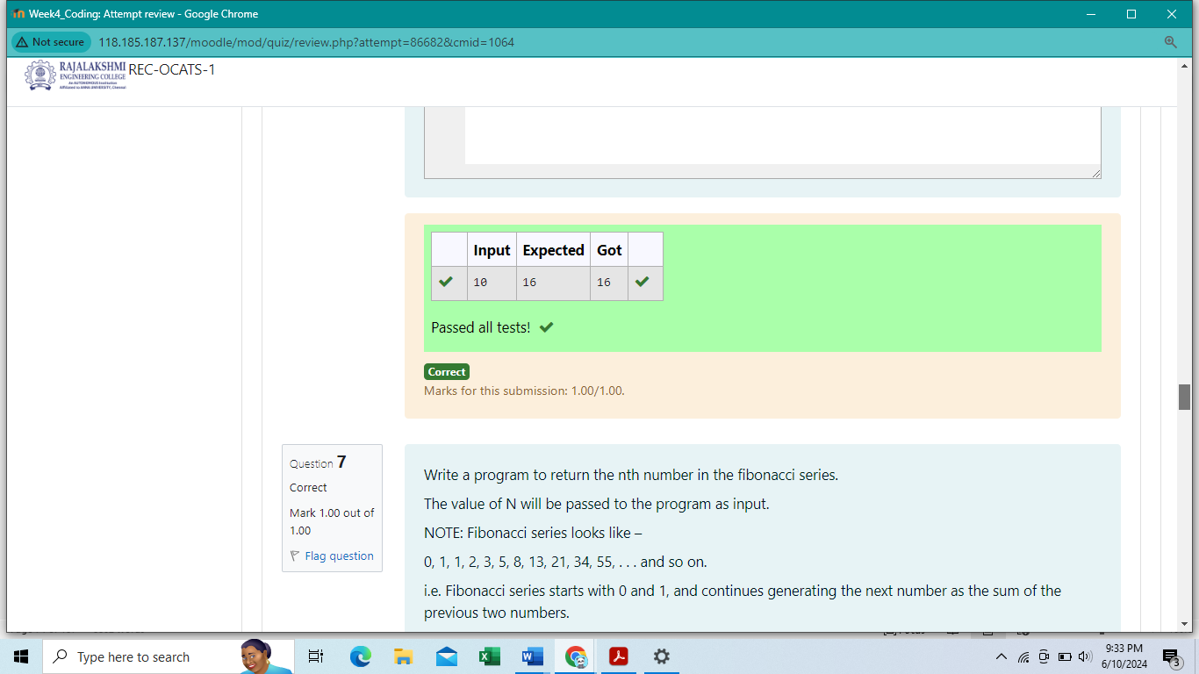

**Ex. No. : 4.4 Date:**

**Register No.: 231401011 Name: ANURAHINI S**

**Next Perfect Square**

Given a number N, find the next perfect square greater than N.

NOTE: Fibonacci series looks like –

0, 1, 1, 2, 3, 5, 8, 13, 21, 34, 55, . . . and so on.

i.e. Fibonacci series starts with 0 and 1, and continues generating the next number as the sum of the previous two numbers.

• first Fibonacci number is 0,

• second Fibonacci number is 1,

• third Fibonacci number is 1,

• fourth Fibonacci number is 2,

• fifth Fibonacci number is 3,

• sixth Fibonacci number is 5,

• seventh Fibonacci number is 8, and so on.

**For example:**

**Input:**

**7**

**Output**

**8**

**Program**

import math

n=int(input ())

n1=math.sqrt(n)

n2=n1+1

m=int (n2)

print (m**2)

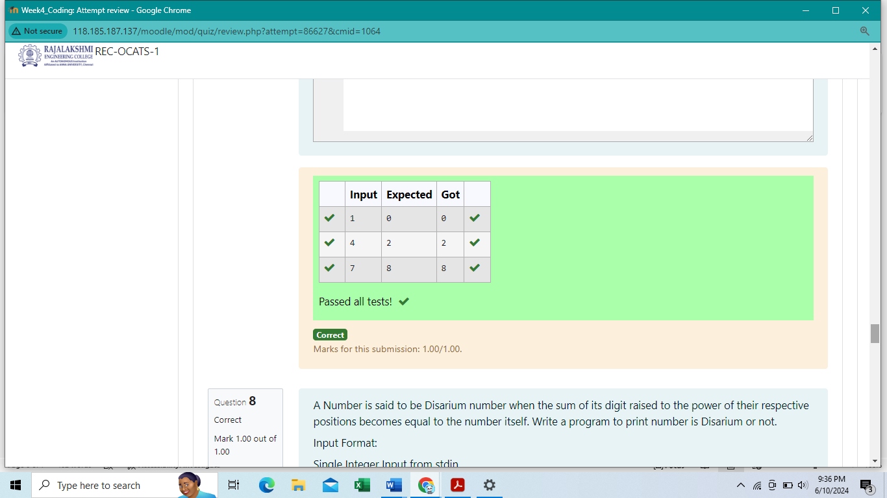

**Ex. No. : 4.5 Date:**

**Register No.: 231401011 Name: ANURAHINI S**

**Nth Fibonacci**

Write a [program](https://www.rajalakshmicolleges.net/moodle/mod/quiz/view.php?id=3478) to return the nth number in the fibonacci series. The value of N will be passed to the [program](https://www.rajalakshmicolleges.net/moodle/mod/quiz/view.php?id=3478) as input.

Input Format:

Single Integer Input from stdin.

Output Format:

Yes or No.

Example Input:

175

Output:

Yes

Explanation

1^1 + 7^2 +5^3 = 175

Example Input:

123

Output:

No

**For example:**

| **Input** | **Result** |
| --- | --- |
| 175 | Yes |
| 123 | No |

Program

n=int (input ())

if n<2:

print (n-1)

else:

n=n-1

fs= [0,1]

for i in range (1, n) :

print(fs [n])

s.append(fs[i]+fs[i-1])

print(fs[n])

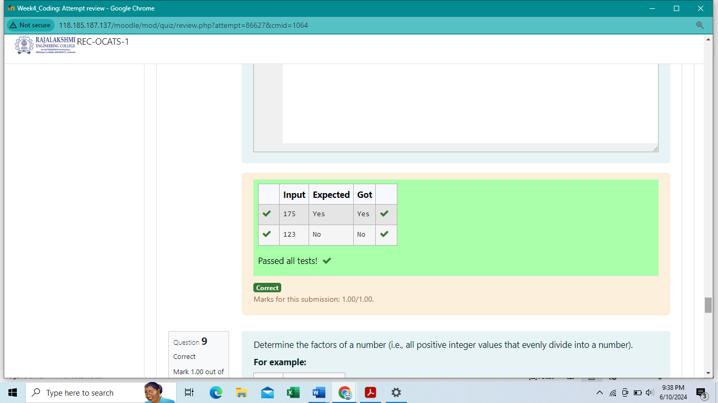

**Ex. No. : 4.6 Date:**

**Register No.: 231401011 Name: ANURAHINI S**

**Disarium Number**

A Number is said to be Disarium number when the sum of its digit raised to the power of their respective positions becomes equal to the number itself. Write a [program](https://www.rajalakshmicolleges.net/moodle/mod/quiz/view.php?id=3478) to print number is Disarium or not.

Sample Test Cases

Test Case 1

Input

4

Output

1234

Explanation:

as input is 4, have to take 4 terms.

1 + 11 + 111 + 1111

Test Case 2

Input

6

Output

123456

**For example:**

| **Input** | **Result** |
| --- | --- |
| 3 | 123 |
|  |  |

**Program**

import math

a=int (input ( ))

b= (pow(10, a+1) -10-9*a) /81

print(' {:.0f}'.format (b))

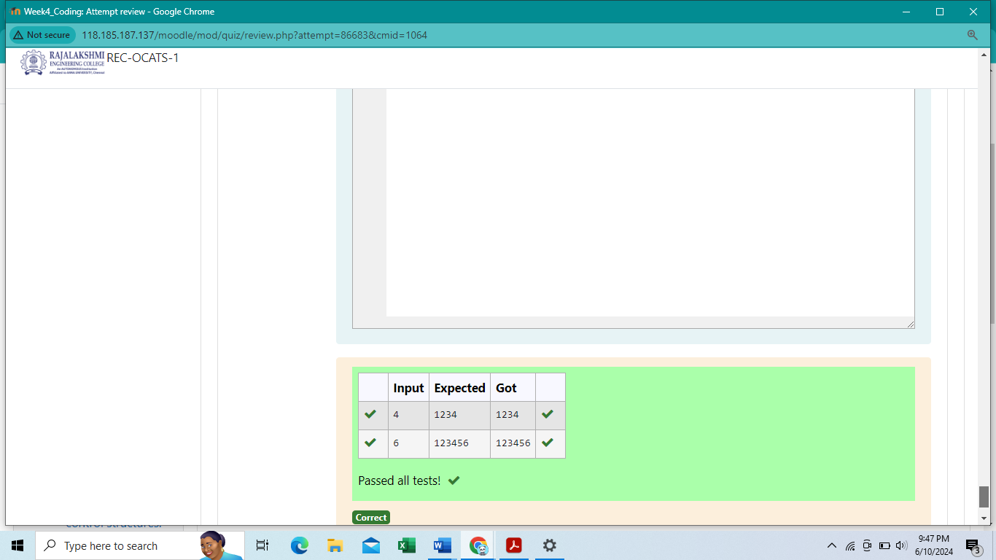

**Ex. No. : 4.7 Date:**

**Register No.: 231401011 Name: ANURAHINI S**

**Sum of Series**

Write a program to find the sum of the series 1 +11 + 111 + 1111 + . . . + n terms (n will be given as input from the user and sum will be the output)

**For example:**

| **Input** | **Result** |
| --- | --- |
| 292 | 2 |
| 1015 | 3 |

Program

Def digit(N):

Return len(set(str(N)))

N=int(input())

Print(digit(N))

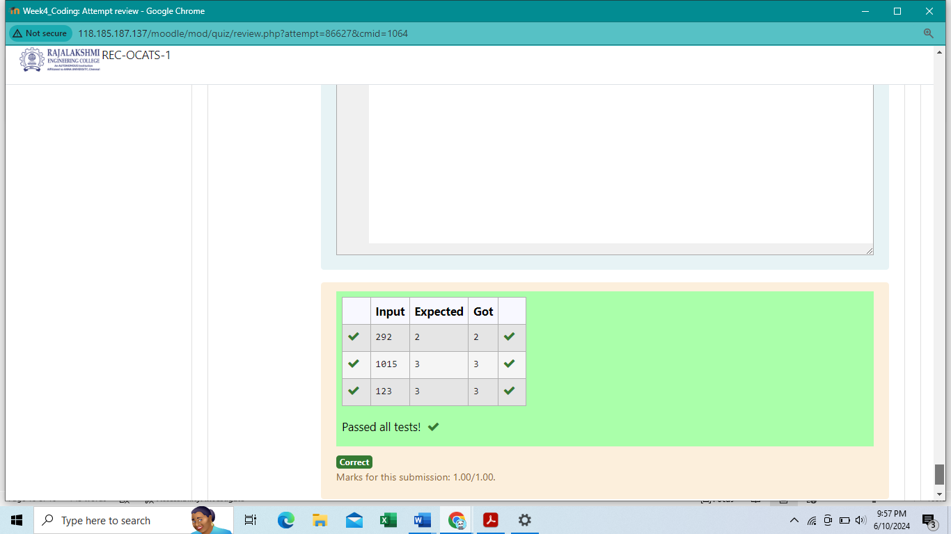

**Ex. No. : 4.8 Date:**

**Register No.: 231401011 Name: ANURAHINI S**

**Unique Digit Count**

Write a program to find the count of unique digits in a given number N. The number will be passed to the program as an input of type int.

Assumption: The input number will be a positive integer number >= 1 and <= 25000.

For e.g.

If the given number is 292, the program should return 2 because there are only 2 unique digits '2' and '9' in this number

If the given number is 1015, the program should return 3 because there are 3 unique digits in this number, '1', '0', and '5'.

Input Format:

Single Integer input.

Output Format:

Output displays Yes if condition satisfies else prints No.

Example Input:

14

Output:

Yes

Example Input:

13

Output:

No

Program

a=int (input ())

if a%2==0 or a%3=-0 or a%5==0 or a%7==0 or a%9==0:

print("Yes")

else:

print ("No")

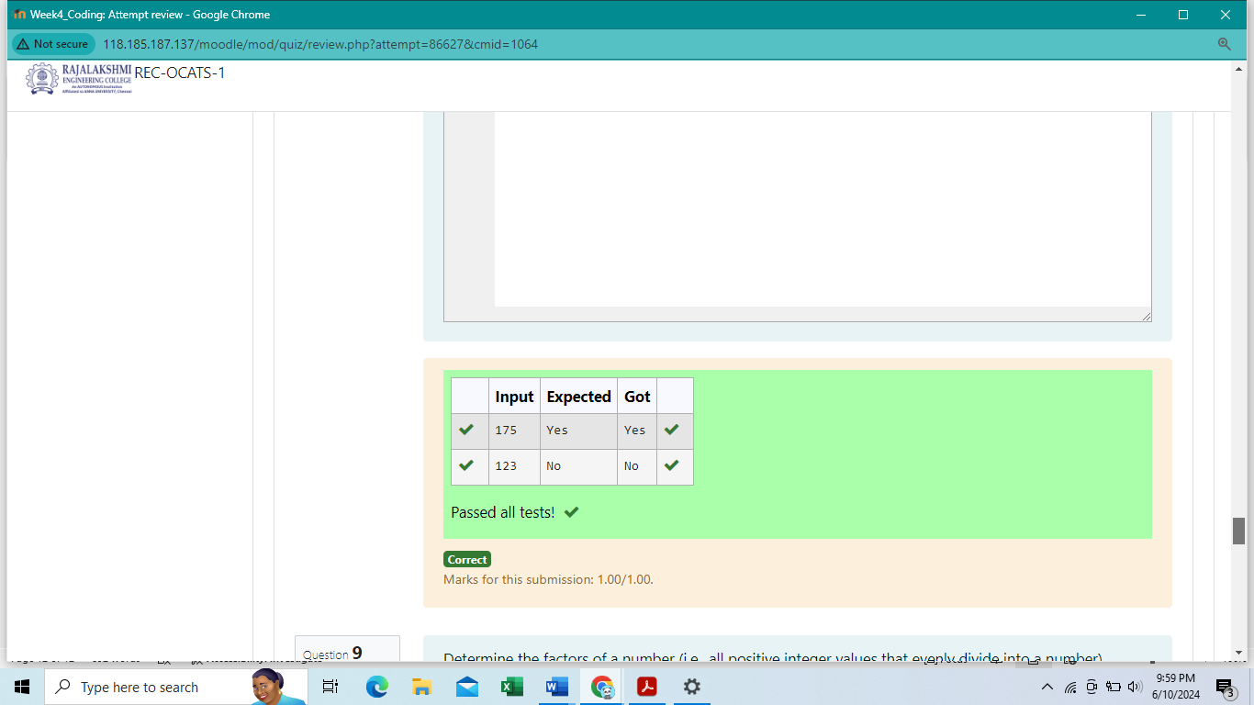

**Ex. No. : 4.9 Date:**

**Register No.: 231401011 Name: ANURAHINI S**

**Product of single digit**

Given a positive integer N, check whether it can be represented as a product of single digit numbers.

Input Format:

Single integer input.

Output Format:

Yes or No.

Example Input:

24

Output:

Yes

Example Input:

26

Output:

No

**For example:**

| **Input** | **Result** |
| --- | --- |
| 24 | Yes |

Program

def square(n) :

if (n%4=-0):

return

else

return ‘No’

n=int (input ())

print (square (n))

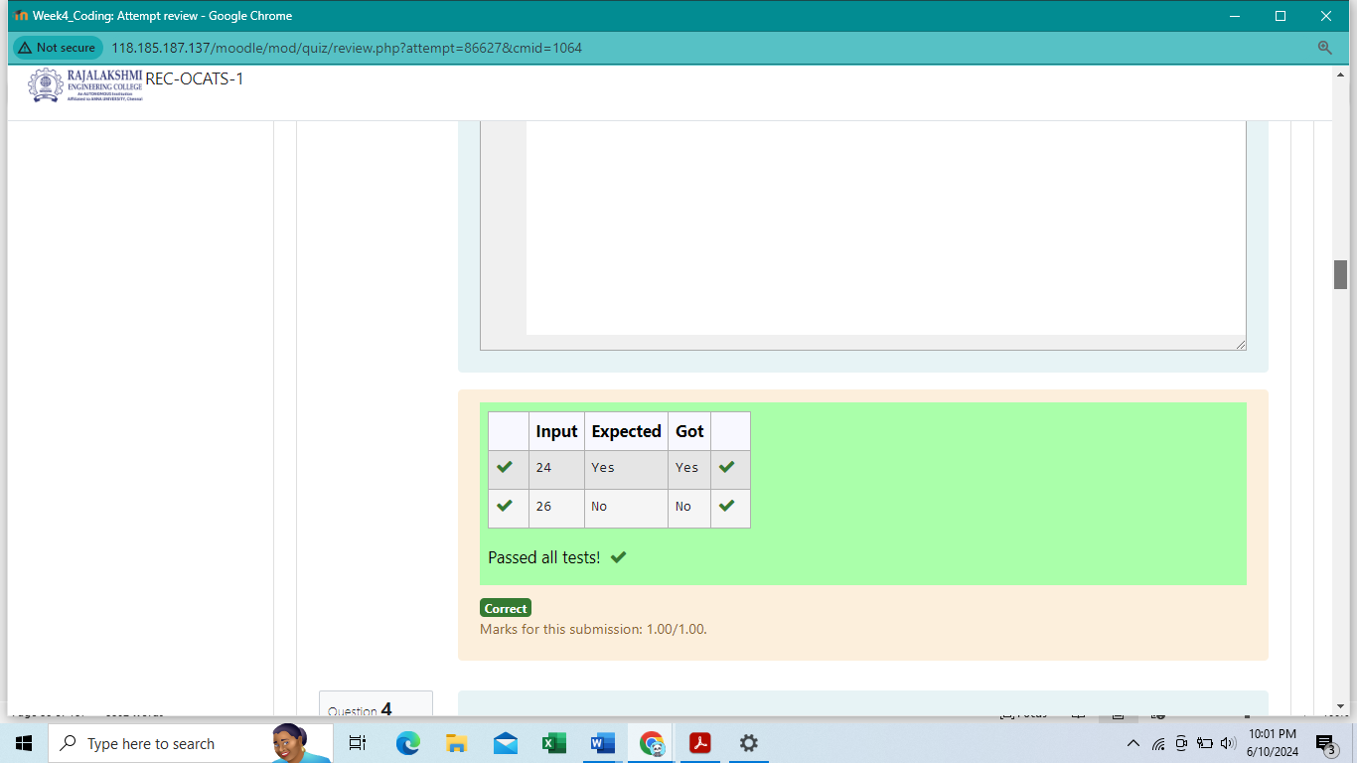

**Ex. No. : 4.10 Date:**

**Register No.: 231401011 Name: ANURAHINI S**

**Perfect Square After adding One**

Given an integer N, check whether N the given number can be made a perfect square after adding 1 to it.

Program

def square (n) :

if(n%4==0):

return "Yes"

else:

return "No"

n=int (input ( ))

print (square (n))

